**Movement and feeding in sea urchins.**

Obtain a living sea urchin and place in a small dish under the dissecting scope.

Focus on the tube feet and see if you can observe the cycle of expansion and contraction of feet that enable the animal to move.



**Film tube feet in motion. Is there a rhythm to the motion and can you time regular waver of contraction and relaxation?**

Pedicellaria in the sea urchin are found on the apical surface. We have purple and tuxedo urchins. To locate pedicellaria on the tuxedo urchin focus on what appears to be smooth area between the spines. Various functions have been attributed to these structures. They have implecated in defense as well as feeding. They have been observed cleaning potential parasites and sediment off the animals. Pedicellaria of a few species may contain venom. which aids in their defensive function. They also have been observed catching small prey. Found in starfish and sea urchins, two top predators (with the exception of a few herbivores) in all the ecosystems they have been found, one wonders why they need to use these for supplemental feeding!

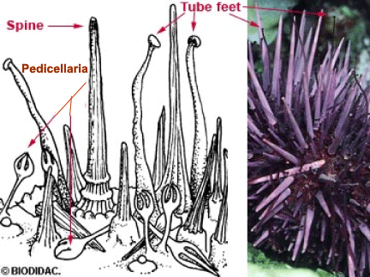

**Obtain a short film of pedicellaria movement** . Also compare the spine found on the sea urchins and brittlestar in your journal. Are the spines for example, more motile in the sea urchin?

**Exercise eight: Aristotle’s lantern,**

Before returning your specimen to the larger dish turn it over on its distal side . Can you locate Aristotle’s lantern or the “jaws” used by the sea urchin to feed? These jaws are fairly large and capable of crushing and tearing apart shells and other protective layering of prey (including other echinoderms) and the reason why most sea urchins are not considered reef safe.

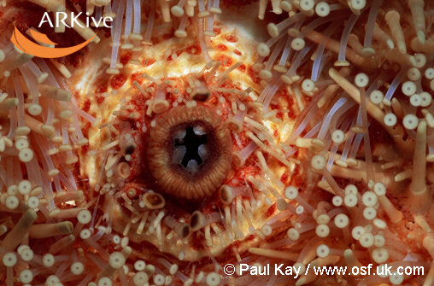

**Take a video of the aristotle's lantern in the sea urchins available.**

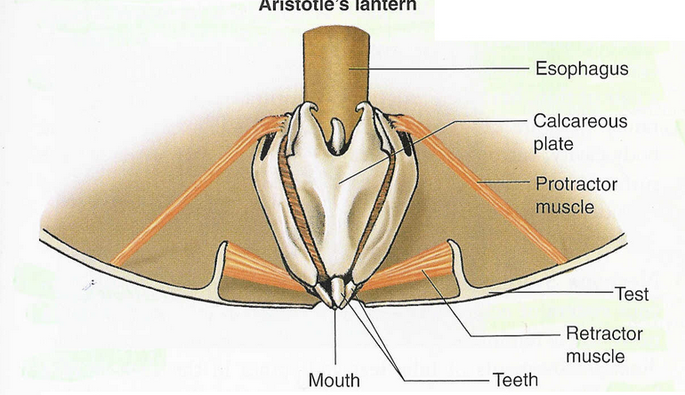

At the end of this lab, you should be able to compare movement and feeding in 3 echinoderms, sea urchins, sea stars/or brittle stars and sea cucumbers (refer to your notes from last week). You should also be able to compare external anatomy that may be utilized in one form versus the other in “circulation”, movement and feeding.